Remove this phrase: “If you have not received your room details, please reach out to Anjani or Varun Ram directly.” - Details to be shared by planner closer to the date! Guests don’t have to worry about it

For reaching out - these are the contacts in addition to the email (email id: anjanivarunwedding@gmail.com):
Anjani Agrawal - +1 832-853-9365
Archna Agrawal - +1 832-671-3177
Varun Khandavalli - ‭+1 (908) 500-2944‬
Ratnasri Khandavalli - + 1 908 872 9153

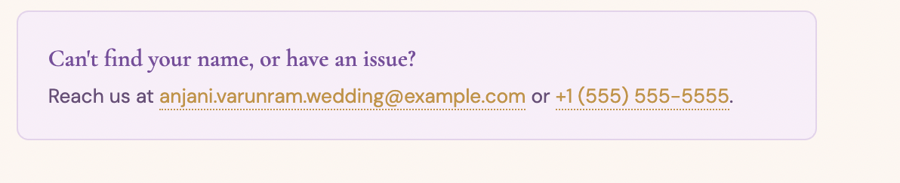

Replace “Maharashtra” with “India”
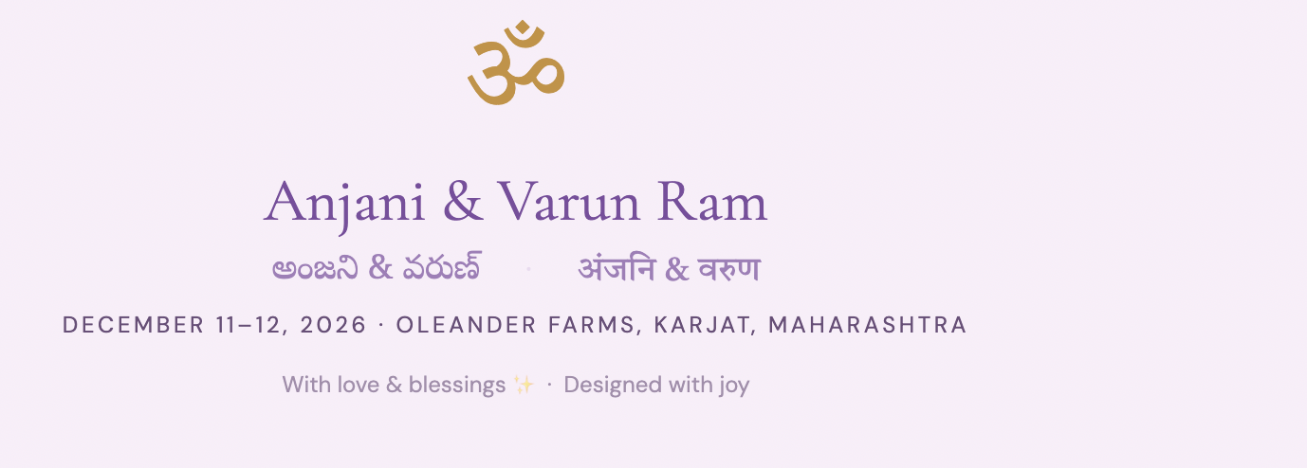

Rephrase this “A traditional Hindu wedding filled with color, music, devotion, and love across two unforgettable days.” to phrase it more so as a blend of telugu and marwadi cultures and filled with dance too

Welcome lunch & mehndi attire should be: Colorful ethnic or fusion wear—light, breezy, and fun

Sangeet attire should be: Chic, glam evening ensembles with a touch of sparkle

Wedding ceremony attire should be: Timeless elegance in refined traditional or formal attire. Kindly avoid shades of orange and sage green
Snatekam & brunch attire add: Kurta pajama

Refine the dress to celebrate section based on the directions above. I have added photos in the folder to include for all of them - make sure you resize the photos to be all consistent.

Download link of oleander farms doesn’t work
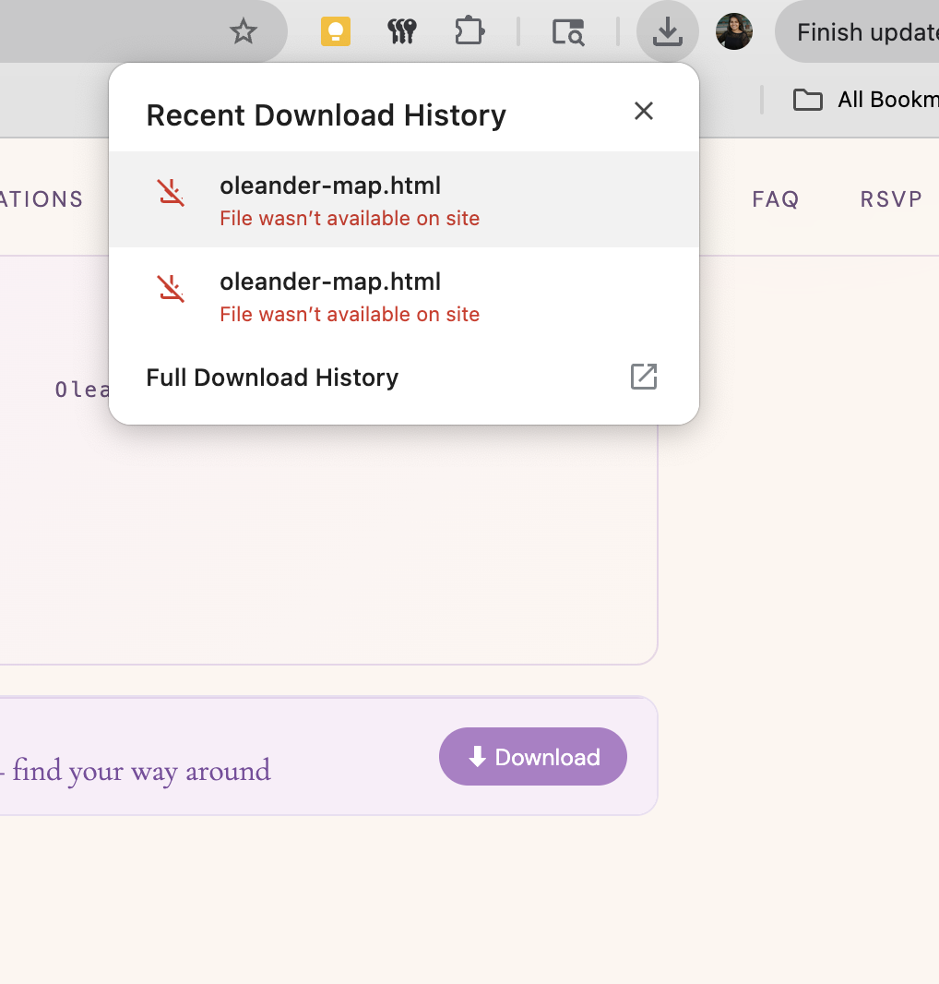

Bride is not telugu - she is marwadi (comes from Mumbai, India and lived all over the world). Also the parts of the smile seem very cliche & cheesy - make it more fun. Also change the “telugu roots” pil. Make the blurb more fun in general just like varun’s.
l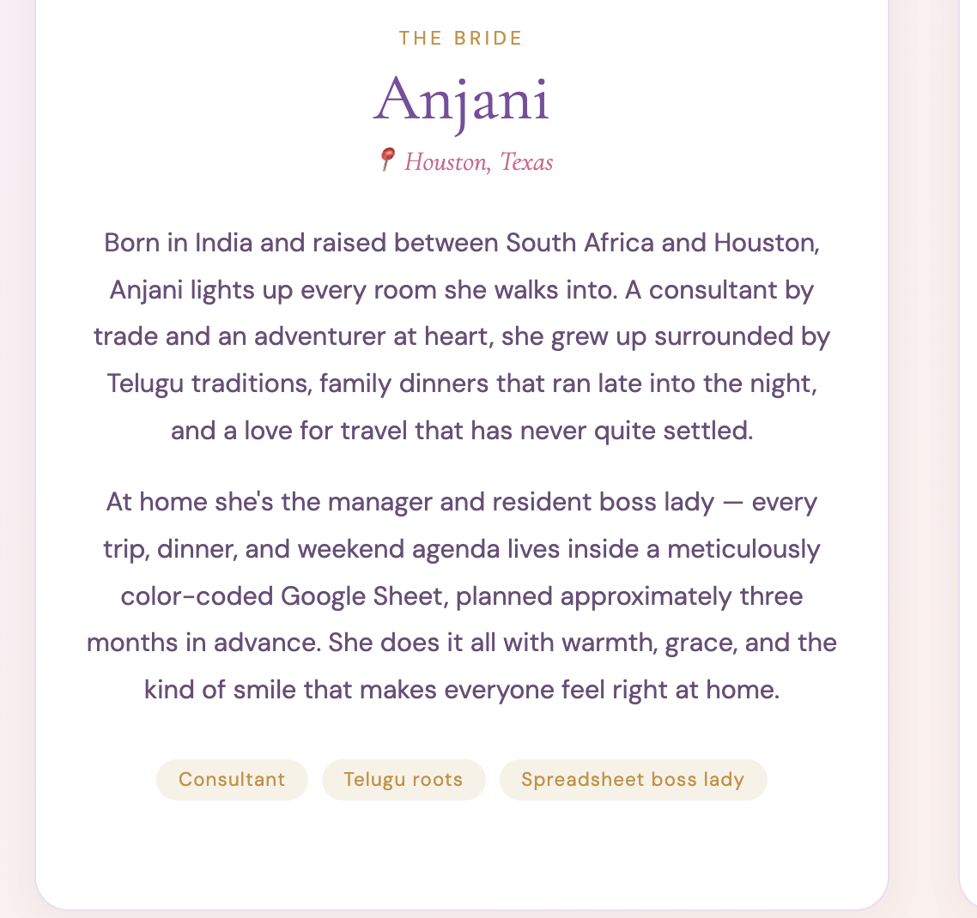

We went to DC for the pandas - not the cherry blossoms. And we went to Bay area for the sunshine and hiking - change SF to bay area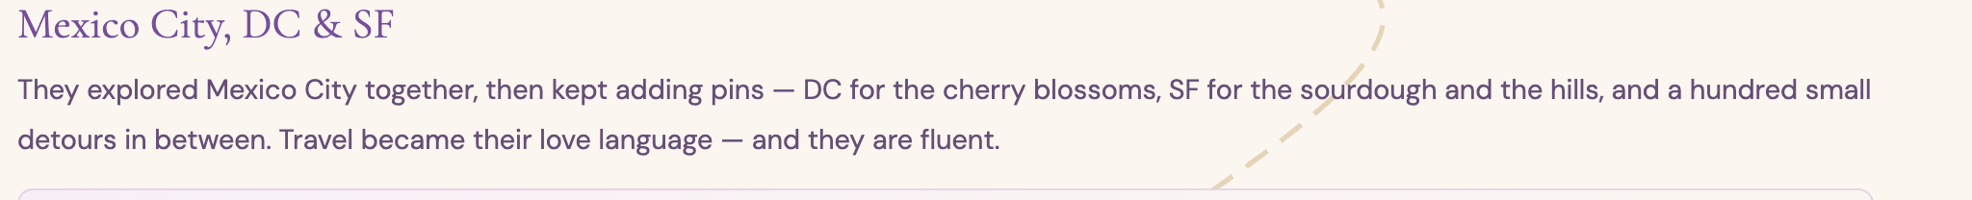

Change “city as their witness” to the tower bridge being the witness
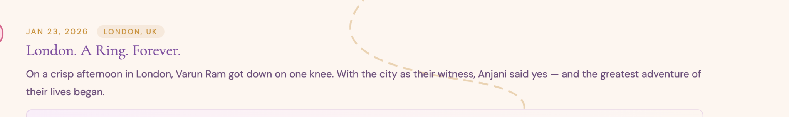

The links in these 2 website pills don’t work 